Cozart HR Consulting, LLC gives:
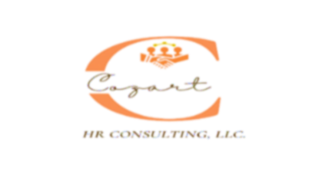
“FIRST CLASS SERVICE”
When it comes to HR helping hands, never settle for less.

Why choose Cozart HR Consulting, LLC?

I am Adrienne Cozart, the owner of Cozart HR Consulting, LLC. I started this company because of my passion for sharing my HR expertise with companies that need an HR professional. Cozart HR Consulting, LLC provides on-site and virtual HR consulting services to businesses with a focus on small businesses. You can feel safe when you select my company. You will get “first-class” services with expert “helping hands” in every HR service. You will receive customized consulting services to meet your company’s basic or complex HR needs.

Does Cozart HR Consulting, LLC have an experienced HR consultant?

YES! I have over 40 years of administrative, human resources management, and consulting experience. I gained board experience working in various industries like healthcare, banking, and the government. I am a trained HR expert with knowledge of quickly evaluating and identifying human capital inefficiencies, recommending effective HR business solutions, developing HR and corporate strategic business models, and ensuring legal compliance. My expertise includes helping organizations address diversity-equity-inclusion by building a diverse culture, increasing employee engagement, and directing all HR services.
As your HR consultant, I offer other unique skills based on my extensive nationwide and community service work. The volunteer service work and recognitions allow me to add a compassionate/passionate touch to my consultive services. These vital skills are critical when addressing work and home balance issues, mentoring, coaching, and having the ability to take an administratively deeper look at the overall business operations and determine a business’s workforce and human resource needs.

A little more about me: I have a Bachelor’s Degree, Master’s Degree in Business Administration, and I am currently a Doctoral student (completion date: May 2023). I have various HR and Administrative certifications.

What are our Mission and Vision?
Cozart HR Consulting, LLC - Mission Statement:
Cozart HR Consulting, LLC provides its customer with a high-quality consulting experience by delivering comprehensive human resource services.

Cozart HR Consulting. LLC – Vision Statement

- To provide first-class expert HR consulting services to small businesses with limited or no access to a human resource professional.
- To provide customized human resource consulting services to help businesses increase employee retention by having an engaged workforce.

